Topic 3: Divide and Conquer

Experiment 1: Maximum and Minimum in an Array (Divide and Conquer)
Aim: Write a program to find both the maximum and minimum values in an array using the divide-and-conquer approach: split the array in half, recursively find the min/max of each half, then combine the two results.
Program:
def max_min(arr, low, high):
# Base case: only one element
if low == high:
return arr[low], arr[low]

# Base case: two elements
if high == low + 1:
if arr[low] < arr[high]:
return arr[low], arr[high]
else:
return arr[high], arr[low]

# Divide the array into two halves and conquer recursively
mid = (low + high) // 2
min1, max1 = max_min(arr, low, mid)
min2, max2 = max_min(arr, mid + 1, high)

# Combine: compare the results of both halves
return min(min1, min2), max(max1, max2)

test_cases = [
[5, 7, 3, 4, 9, 12, 6, 2],
[1, 3, 5, 7, 9, 11, 13, 15, 17],
[22, 34, 35, 36, 43, 67, 12, 13, 15, 17],
]

for arr in test_cases:
minimum, maximum = max_min(arr, 0, len(arr) - 1)
print(f"Input: N = {len(arr)}, a[] = {arr}")
print(f"Output: Min = {minimum}, Max = {maximum}")
print()

Output:
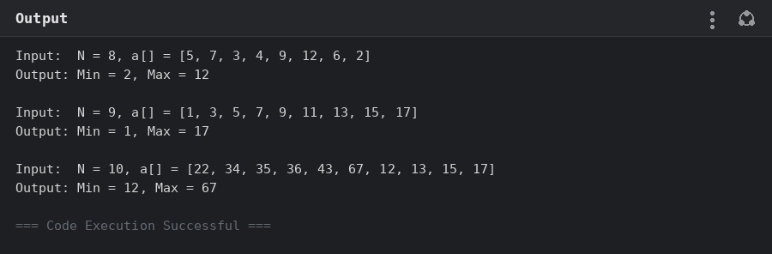

Experiment 2: Maximum and Minimum in a Sorted Array
Aim: Apply the same divide-and-conquer max/min procedure to an array that is already sorted in ascending order, and verify it still finds the correct minimum and maximum values.
Program:
def max_min(arr, low, high):
if low == high:
return arr[low], arr[low]

if high == low + 1:
if arr[low] < arr[high]:
return arr[low], arr[high]
else:
return arr[high], arr[low]

mid = (low + high) // 2
min1, max1 = max_min(arr, low, mid)
min2, max2 = max_min(arr, mid + 1, high)

return min(min1, min2), max(max1, max2)

test_cases = [
[2, 4, 6, 8, 10, 12, 14, 18],
[11, 13, 15, 17, 19, 21, 23, 35, 37],
[22, 34, 35, 36, 43, 67, 12, 13, 15, 17],
]

for arr in test_cases:
minimum, maximum = max_min(arr, 0, len(arr) - 1)
print(f"Input: N = {len(arr)}, a[] = {arr}")
print(f"Output: Min = {minimum}, Max = {maximum}")
print()

print("Note: for an already sorted (ascending) array, min = a[0] and")
print("max = a[N-1] directly, but the same divide-and-conquer procedure")
print("above still works correctly without relying on that ordering.")
Output:
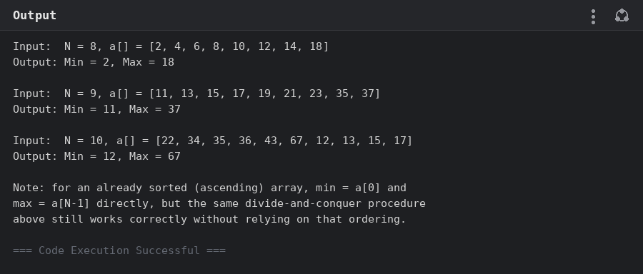

Experiment 3: Merge Sort
Aim: Implement Merge Sort: recursively divide the array into halves, sort each half, and merge the two sorted halves back together.
Program:
def merge(left, right):
result = []
i = j = 0
while i < len(left) and j < len(right):
if left[i] <= right[j]:
result.append(left[i])
i += 1
else:
result.append(right[j])
j += 1
result.extend(left[i:])
result.extend(right[j:])
return result

def merge_sort(arr):
if len(arr) <= 1:
return arr
mid = len(arr) // 2
left = merge_sort(arr[:mid])
right = merge_sort(arr[mid:])
return merge(left, right)

test_cases = [
[31, 23, 35, 27, 11, 21, 15, 28],
[22, 34, 25, 36, 43, 67, 52, 13, 65, 17],
]

for arr in test_cases:
sorted_arr = merge_sort(arr)
print(f"Input: N = {len(arr)}, a[] = {arr}")
print("Output:", ",".join(map(str, sorted_arr)))
print()
Output:
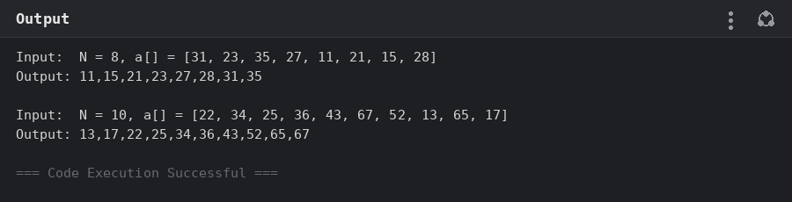

Experiment 4: Merge Sort with Comparison Counting
Aim: Modify the Merge Sort implementation to count the number of element comparisons made during the merge step, and print this count along with the sorted array.
Program:
comparison_count = 0

def merge(left, right):
global comparison_count
result = []
i = j = 0
while i < len(left) and j < len(right):
comparison_count += 1
if left[i] <= right[j]:
result.append(left[i])
i += 1
else:
result.append(right[j])
j += 1
result.extend(left[i:])
result.extend(right[j:])
return result

def merge_sort(arr):
if len(arr) <= 1:
return arr
mid = len(arr) // 2
left = merge_sort(arr[:mid])
right = merge_sort(arr[mid:])
return merge(left, right)

test_cases = [
[12, 4, 78, 23, 45, 67, 89, 1],
[38, 27, 43, 3, 9, 82, 10],
]

for arr in test_cases:
comparison_count = 0
sorted_arr = merge_sort(arr)
print(f"Input: N = {len(arr)}, a[] = {arr}")
print("Sorted array:", ",".join(map(str, sorted_arr)))
print(f"Comparisons made: {comparison_count}")
print()
Output:
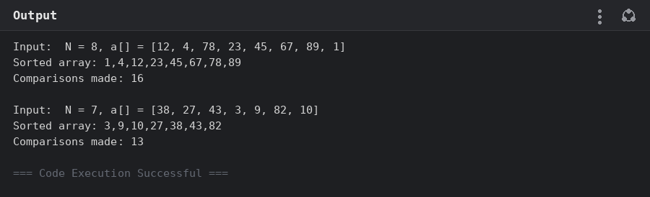

Experiment 5: Quick Sort (First Element as Pivot)
Aim: Implement Quick Sort using the first element of each sub-array as the pivot. Show the array after each partition step and after each recursive call, until the entire array is sorted.
Program:
def quick_sort(arr, low, high, depth=0):
if low < high:
pivot_index = partition(arr, low, high)
print(f"{' ' * depth}Partitioned around pivot {arr[pivot_index]}: {arr}")
quick_sort(arr, low, pivot_index - 1, depth + 1)
quick_sort(arr, pivot_index + 1, high, depth + 1)

def partition(arr, low, high):
# First element as pivot
pivot = arr[low]
i = low + 1
for j in range(low + 1, high + 1):
if arr[j] < pivot:
arr[i], arr[j] = arr[j], arr[i]
i += 1
arr[low], arr[i - 1] = arr[i - 1], arr[low]
return i - 1

def run(arr):
arr = arr.copy()
print(f"Input: N = {len(arr)}, a[] = {arr}")
quick_sort(arr, 0, len(arr) - 1)
print("Output:", ",".join(map(str, arr)))
print()

run([10, 16, 8, 12, 15, 6, 3, 9, 5])
run([12, 4, 78, 23, 45, 67, 89, 1])
run([38, 27, 43, 3, 9, 82, 10])
Output:
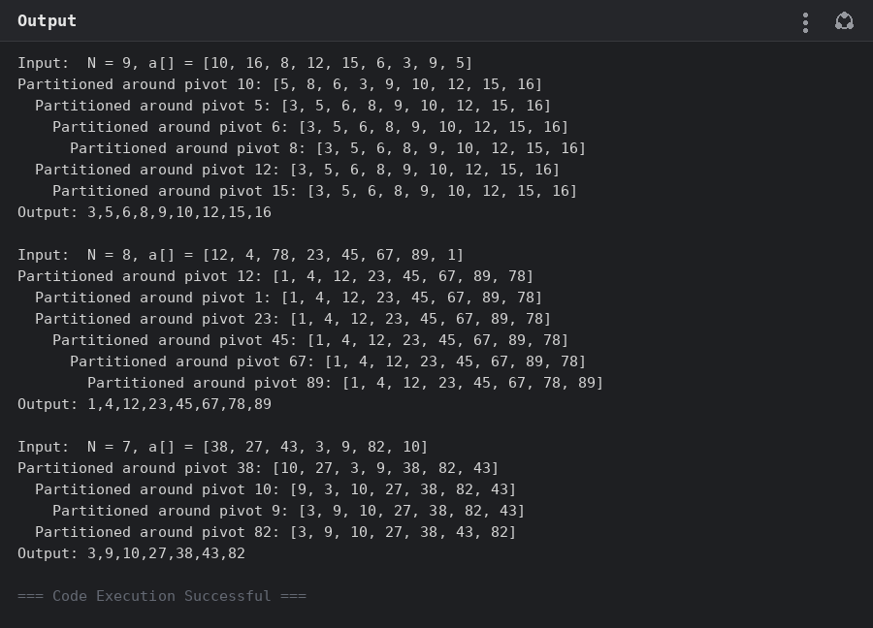

Experiment 6: Quick Sort (Middle Element as Pivot)
Aim: Implement Quick Sort using the middle element of each sub-array as the pivot. Show the array after each partition step and after each recursive call, until the entire array is sorted.
Program:
def quick_sort(arr, low, high, depth=0):
if low < high:
pivot_index = partition(arr, low, high)
print(f"{' ' * depth}Partitioned around pivot {arr[pivot_index]}: {arr}")
quick_sort(arr, low, pivot_index - 1, depth + 1)
quick_sort(arr, pivot_index + 1, high, depth + 1)

def partition(arr, low, high):
# Middle element as pivot: swap it to the front, then partition as usual
mid = (low + high) // 2
arr[low], arr[mid] = arr[mid], arr[low]
pivot = arr[low]
i = low + 1
for j in range(low + 1, high + 1):
if arr[j] < pivot:
arr[i], arr[j] = arr[j], arr[i]
i += 1
arr[low], arr[i - 1] = arr[i - 1], arr[low]
return i - 1

def run(arr):
arr = arr.copy()
print(f"Input: N = {len(arr)}, a[] = {arr}")
quick_sort(arr, 0, len(arr) - 1)
print("Output:", ",".join(map(str, arr)))
print()

run([19, 72, 35, 46, 58, 91, 22, 31])
run([31, 23, 35, 27, 11, 21, 15, 28])
run([22, 34, 25, 36, 43, 67, 52, 13, 65, 17])
Output:
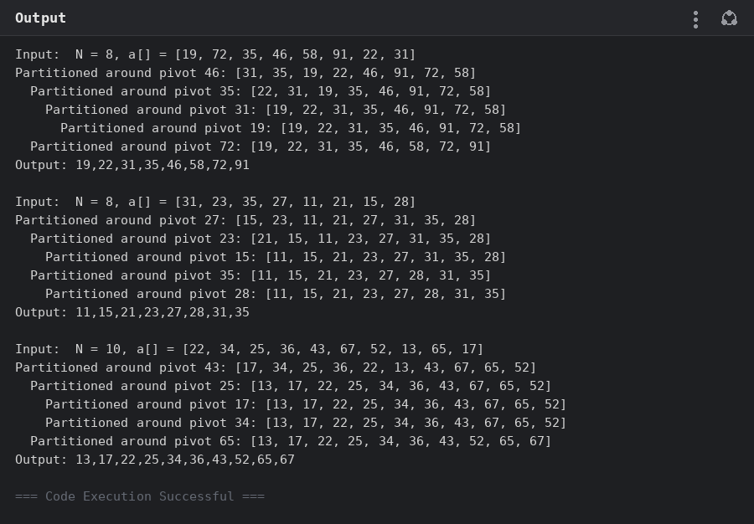

Experiment 7: Binary Search with Comparison Counting
Aim: Implement Binary Search to find the position of a target element in a sorted array, and modify it to count the number of comparisons made during the search.
Program:
def binary_search(arr, key):
"""Returns the 1-indexed position of key in arr, and the number of
element comparisons made, or (-1, comparisons) if not found."""
low, high = 0, len(arr) - 1
comparisons = 0
while low <= high:
mid = (low + high) // 2
comparisons += 1
if arr[mid] == key:
return mid + 1, comparisons
elif arr[mid] < key:
low = mid + 1
else:
high = mid - 1
return -1, comparisons

test_cases = [
([5, 10, 15, 20, 25, 30, 35, 40, 45], 20),
([10, 20, 30, 40, 50, 60], 50),
([21, 32, 40, 54, 65, 76, 87], 32),
]

for arr, key in test_cases:
position, comparisons = binary_search(arr, key)
print(f"Input: N = {len(arr)}, a[] = {arr}, search key = {key}")
print(f"Output: {position}")
print(f"Comparisons made: {comparisons}")
print()
Output:
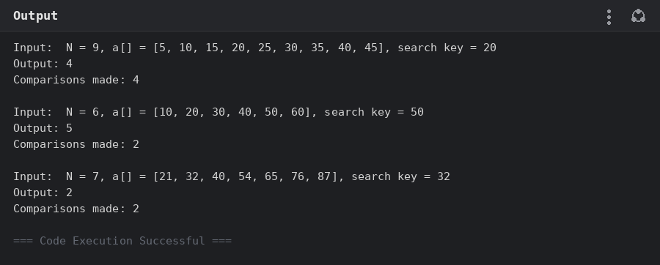

Experiment 8: Binary Search — Step-by-Step Midpoint Trace
Aim: Trace Binary Search step by step on a sorted array, showing the low/high/mid calculations at each step, and discuss what happens to correctness and performance if the input array is not sorted.
Program:
def binary_search_verbose(arr, key):
low, high = 0, len(arr) - 1
step = 1
while low <= high:
mid = (low + high) // 2
print(f"Step {step}: low={low}, high={high}, mid={mid} -> arr[mid]={arr[mid]}")
if arr[mid] == key:
print(f" Found {key} at position {mid + 1}")
return mid + 1
elif arr[mid] < key:
print(f" arr[mid] < key, search right half")
low = mid + 1
else:
print(f" arr[mid] > key, search left half")
high = mid - 1
step += 1
print(f" {key} not found")
return -1

test_cases = [
([3, 9, 14, 19, 25, 31, 42, 47, 53], 31),
([13, 19, 24, 29, 35, 41, 42], 42),
([20, 40, 60, 80, 100, 120], 60),
]

for arr, key in test_cases:
print(f"Input: N = {len(arr)}, a[] = {arr}, search key = {key}")
result = binary_search_verbose(arr, key)
print(f"Output: {result}")
print()

print("If the array were NOT sorted:")
print("- Correctness breaks: the mid-point comparison assumes everything")
print(" to the left of a smaller value and to the right of a larger one")
print(" is ordered accordingly, so the search can discard the half that")
print(" actually contains the key and return the wrong answer or -1.")
print("- Performance no longer helps either: to guarantee correctness on")
print(" unsorted data you would have to fall back to a linear scan,")
print(" losing Binary Search's O(log n) advantage entirely.")
Output:
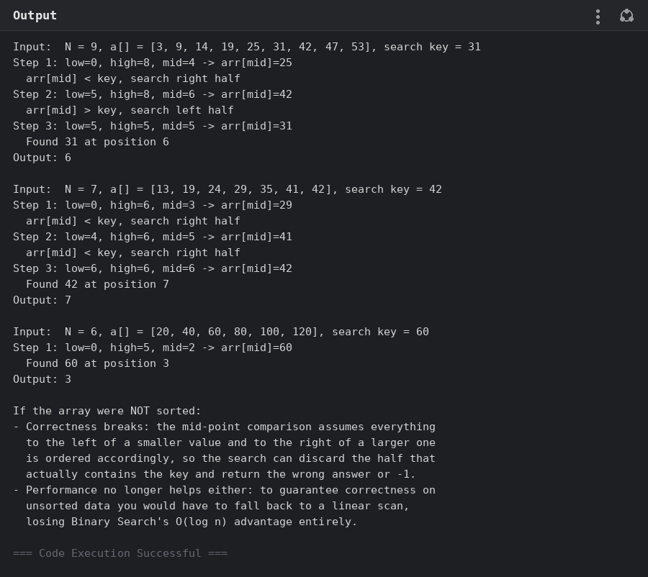

Experiment 9: K Closest Points to the Origin
Aim: Given an array of 2D points and an integer k, return the k points closest to the origin (0, 0), using squared Euclidean distance to rank the points.
Program:
def k_closest(points, k):
return sorted(points, key=lambda p: p[0] ** 2 + p[1] ** 2)[:k]

test_cases = [
([[1, 3], [-2, 2], [5, 8], [0, 1]], 2),
([[1, 3], [-2, 2]], 1),
([[3, 3], [5, -1], [-2, 4]], 2),
]

for points, k in test_cases:
result = k_closest(points, k)
print(f"Input: points = {points}, k = {k}")
print(f"Output: {result}")
print()
Output:
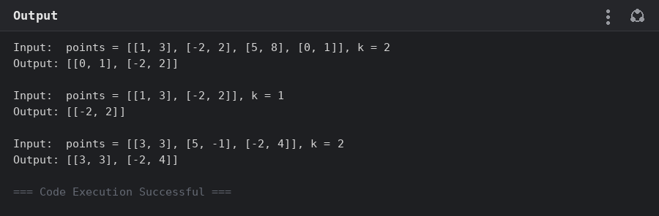

Experiment 10: 4Sum II — Counting Zero-Sum Tuples
Aim: Given four integer lists A, B, C, D, count how many tuples (i, j, k, l) exist such that A[i] + B[j] + C[k] + D[l] equals zero, using a hash map of pairwise sums to avoid an O(n^4) brute force.
Program:
from collections import defaultdict

def four_sum_count(A, B, C, D):
sums_ab = defaultdict(int)
for a in A:
for b in B:
sums_ab[a + b] += 1

count = 0
for c in C:
for d in D:
count += sums_ab.get(-(c + d), 0)
return count

test_cases = [
([1, 2], [-2, -1], [-1, 2], [0, 2]),
([0], [0], [0], [0]),
]

for A, B, C, D in test_cases:
result = four_sum_count(A, B, C, D)
print(f"Input: A = {A}, B = {B}, C = {C}, D = {D}")
print(f"Output: {result}")
print()
Output:
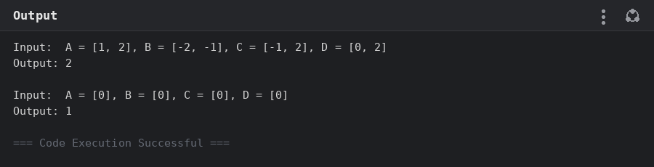

Experiment 11: Median of Medians — Kth Smallest Element
Aim: Implement the Median of Medians algorithm to find the k-th smallest element of an unsorted array with a guaranteed O(n) worst-case running time, by splitting the array into groups of 5 to choose a good pivot.
Program:
def median_of_medians(arr, k):
"""Returns the k-th smallest element (1-indexed) of arr using the
Median of Medians selection algorithm, which guarantees O(n) worst
case by choosing a pivot close to the true median."""
if len(arr) == 1:
return arr[0]

# Split into groups of 5 and find the median of each group
groups = [arr[i:i + 5] for i in range(0, len(arr), 5)]
medians = [sorted(g)[len(g) // 2] for g in groups]

# Recursively find the median of medians to use as the pivot
if len(medians) <= 5:
pivot = sorted(medians)[len(medians) // 2]
else:
pivot = median_of_medians(medians, len(medians) // 2 + 1)

low = [x for x in arr if x < pivot]
high = [x for x in arr if x > pivot]
pivot_count = arr.count(pivot)

if k <= len(low):
return median_of_medians(low, k)
elif k <= len(low) + pivot_count:
return pivot
else:
return median_of_medians(high, k - len(low) - pivot_count)

test_cases = [
([12, 3, 5, 7, 19], 2),
([12, 3, 5, 7, 4, 19, 26], 3),
([1, 2, 3, 4, 5, 6, 7, 8, 9, 10], 6),
]

for arr, k in test_cases:
result = median_of_medians(arr, k)
print(f"Input: arr = {arr}, k = {k}")
print(f"Output: {result}")
print()
Output:
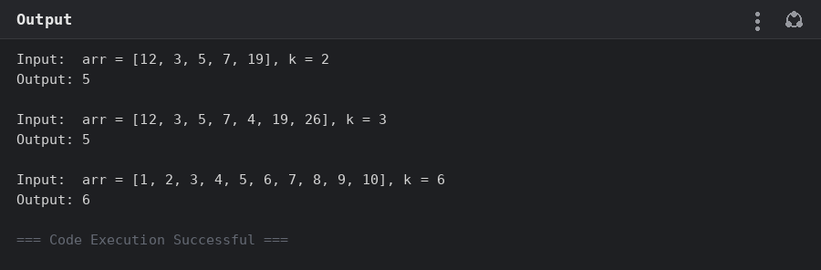

Experiment 12: median_of_medians(arr, k) Function
Aim: Package the Median of Medians selection algorithm as a function median_of_medians(arr, k) that takes an unsorted array and an integer k, and returns the k-th smallest element.
Program:
def median_of_medians(arr, k):
"""Returns the k-th smallest element (1-indexed) of arr."""
if len(arr) == 1:
return arr[0]

groups = [arr[i:i + 5] for i in range(0, len(arr), 5)]
medians = [sorted(g)[len(g) // 2] for g in groups]

if len(medians) <= 5:
pivot = sorted(medians)[len(medians) // 2]
else:
pivot = median_of_medians(medians, len(medians) // 2 + 1)

low = [x for x in arr if x < pivot]
high = [x for x in arr if x > pivot]
pivot_count = arr.count(pivot)

if k <= len(low):
return median_of_medians(low, k)
elif k <= len(low) + pivot_count:
return pivot
else:
return median_of_medians(high, k - len(low) - pivot_count)

test_cases = [
([1, 2, 3, 4, 5, 6, 7, 8, 9, 10], 6),
([23, 17, 31, 44, 55, 21, 20, 18, 19, 27], 5),
]

for arr, k in test_cases:
result = median_of_medians(arr, k)
print(f"Input: arr = {arr}, k = {k}")
print(f"Output: {result}")
print()
Output:
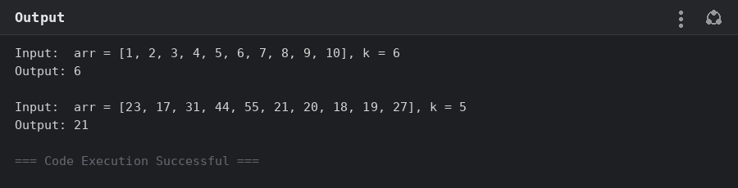

Experiment 13: Meet in the Middle — Subset Sum Closest to Target
Aim: Given an array of integers and a target sum, use the Meet in the Middle technique (split the array in half, enumerate subset sums of each half, then pair them) to find the subset whose sum is closest to the target.
Program:
from itertools import combinations

def all_subset_sums(arr):
sums = []
for r in range(len(arr) + 1):
for combo in combinations(arr, r):
sums.append((sum(combo), combo))
return sums

def closest_subset_sum(arr, target):
"""Meet in the middle: split the array in half, enumerate all subset
sums of each half, then pair a left-half sum with a right-half sum
to get as close to target as possible."""
mid = len(arr) // 2
left, right = arr[:mid], arr[mid:]

left_sums = all_subset_sums(left)
right_sums = sorted(all_subset_sums(right), key=lambda x: x[0])
right_only_sums = [s for s, _ in right_sums]

best_diff = float("inf")
best_subset = ()

for l_sum, l_combo in left_sums:
# Binary search the right-half sums for the value closest to
# (target - l_sum)
needed = target - l_sum
lo, hi = 0, len(right_only_sums) - 1
pos = len(right_only_sums)
while lo <= hi:
m = (lo + hi) // 2
if right_only_sums[m] >= needed:
pos = m
hi = m - 1
else:
lo = m + 1
candidates = [p for p in (pos - 1, pos) if 0 <= p < len(right_only_sums)]
for c in candidates:
r_sum, r_combo = right_sums[c]
total = l_sum + r_sum
diff = abs(total - target)
if diff < best_diff:
best_diff = diff
best_subset = l_combo + r_combo

return best_subset, sum(best_subset)

test_cases = [
([45, 34, 4, 12, 5, 2], 42),
([1, 3, 2, 7, 4, 6], 10),
]

for arr, target in test_cases:
subset, total = closest_subset_sum(arr, target)
print(f"Input: Set[] = {arr}, Target Sum = {target}")
print(f"Output: Closest subset = {subset}, Sum = {total}")
print()
Output:
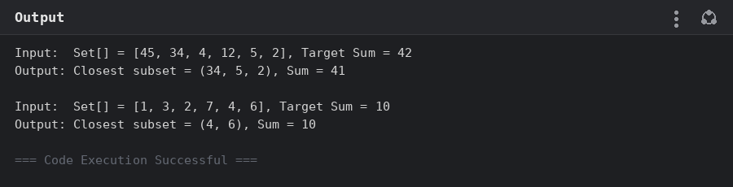

Experiment 14: Meet in the Middle — Exact Subset Sum
Aim: Given an array of integers and an exact target sum E, use the Meet in the Middle technique to determine whether any subset of the array sums exactly to E, returning true or false.
Program:
from itertools import combinations

def all_subset_sums(arr):
sums = set()
for r in range(len(arr) + 1):
for combo in combinations(arr, r):
sums.add(sum(combo))
return sums

def subset_sum_exists(arr, target):
"""Meet in the middle: split the array into two halves, compute every
achievable sum for each half, then check whether some pair of sums
(one from each half) adds up exactly to target."""
mid = len(arr) // 2
left, right = arr[:mid], arr[mid:]

left_sums = all_subset_sums(left)
right_sums = all_subset_sums(right)

for l_sum in left_sums:
if (target - l_sum) in right_sums:
return True
return False

test_cases = [
([1, 3, 9, 2, 7, 12], 15),
([3, 34, 4, 12, 5, 2], 15),
]

for arr, target in test_cases:
result = subset_sum_exists(arr, target)
print(f"Input: arr = {arr}, exact Sum = {target}")
print(f"Output: {result}")
print()
Output:
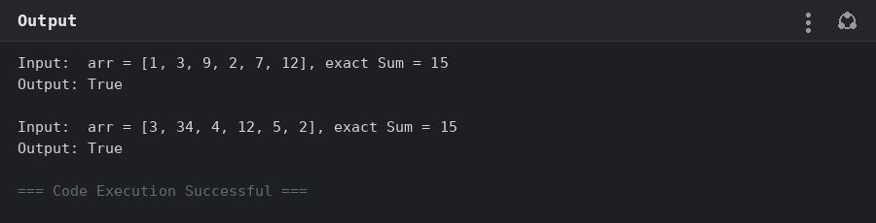

Experiment 15: Strassen's Matrix Multiplication (2x2)
Aim: Use Strassen's algorithm to multiply two 2x2 matrices with only 7 scalar multiplications instead of the usual 8, and verify the resulting product matrix.
Program:
def strassen_2x2(A, B):
a, b = A[0][0], A[0][1]
c, d = A[1][0], A[1][1]
e, f = B[0][0], B[0][1]
g, h = B[1][0], B[1][1]

# Strassen's 7 multiplications
p1 = a * (f - h)
p2 = (a + b) * h
p3 = (c + d) * e
p4 = d * (g - e)
p5 = (a + d) * (e + h)
p6 = (b - d) * (g + h)
p7 = (a - c) * (e + f)

c11 = p5 + p4 - p2 + p6
c12 = p1 + p2
c21 = p3 + p4
c22 = p1 + p5 - p3 - p7

return [[c11, c12], [c21, c22]]

def run(A, B):
C = strassen_2x2(A, B)
print(f"Input: A = {A}, B = {B}")
print(f"Output: C = {C}")
print()

run([[1, 7], [3, 5]], [[1, 3], [7, 5]])
run([[1, 7], [3, 5]], [[6, 8], [4, 2]])
Output:
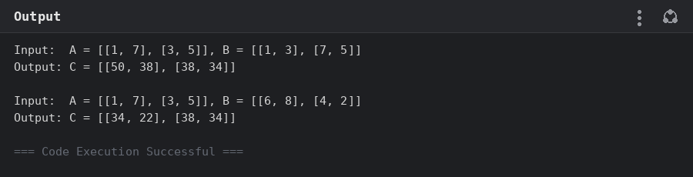

Experiment 16: Karatsuba Multiplication
Aim: Use the Karatsuba algorithm to compute the product of two integers by recursively splitting each number into high and low halves and combining three recursive multiplications instead of four.
Program:
def karatsuba(x, y):
# Base case: fall back to normal multiplication for small numbers
if x < 10 or y < 10:
return x * y

n = max(len(str(x)), len(str(y)))
half = n // 2

high_x, low_x = divmod(x, 10 ** half)
high_y, low_y = divmod(y, 10 ** half)

z0 = karatsuba(low_x, low_y)
z2 = karatsuba(high_x, high_y)
z1 = karatsuba(low_x + high_x, low_y + high_y) - z2 - z0

return z2 * 10 ** (2 * half) + z1 * 10 ** half + z0

x, y = 1234, 5678
result = karatsuba(x, y)

print(f"Input: x = {x}, y = {y}")
print(f"Output: z = {x} x {y} = {result}")
print(f"Verified against built-in multiplication: {result == x * y}")
Output:
